13th June 2016

**WTCC Russia - LADA make it home victorious**

The LADA Sport works team, came out victorious in the FIA WTCC Race of Russia, after an incredibly strong performance last weekend at the Moscow Raceway. Nicky Catsburg’s triumph on the main Race was the Dutch man’s maiden victory in the Championship and followed an impressive weekend for him and the whole LADA team. His veteran colleague, the Italian Gabriele Tarquini also managed LADA’s first win in the opening race for the make’s Vesta TC1 racer, following its debut in 2015.

Gabriele Tarquini had been hoping for wet conditions in Moscow stating that although he does not fancy his chances at the Championship, rain could even out the current distance with the top flight and did take benefit as predicted. Rain had caused the start to be delayed when it fell on the formation lap and drivers given the possibility to swap YOKOHAMA slicks to YOKOHAMA wets for the start.

Tiago Monteiro set off from pole before being overtaken by Muller, then Bennani and the current Champion Lopez and finally Tarquini, who had made a great start from ninth on the grid.

As had been the case in qualifying, the LADA Sport trio excelled in the wet, with Tarquini working his way up to second and reducing the gap to Muller to pass the Frenchman on lap five.

The Italian veteran was able to take his 21st WTCC victory by just over 4 seconds over team-mate Nicky Catsburg, who started from 10th on the grid and passed Citroen’s Yvan Muller for second place on lap nine. Muller finished a distant third for Citroen.

LADA Sport were jubilant with the incredible result, and such dominance on wet. It remains to be seen if they will be able to keep such form, in hotter, less wet conditions.

The next race in the FIA WTCC Championship which has YOKOHAMA as Official Tyre supplier is the Race of Portugal scheduled from the 24th -26th June.

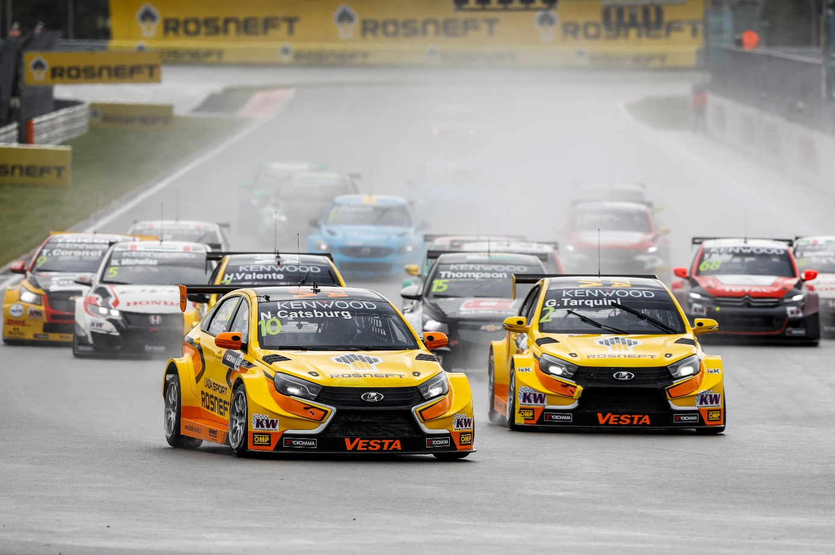

*LADA Sport sing in the rain after impressive performance*

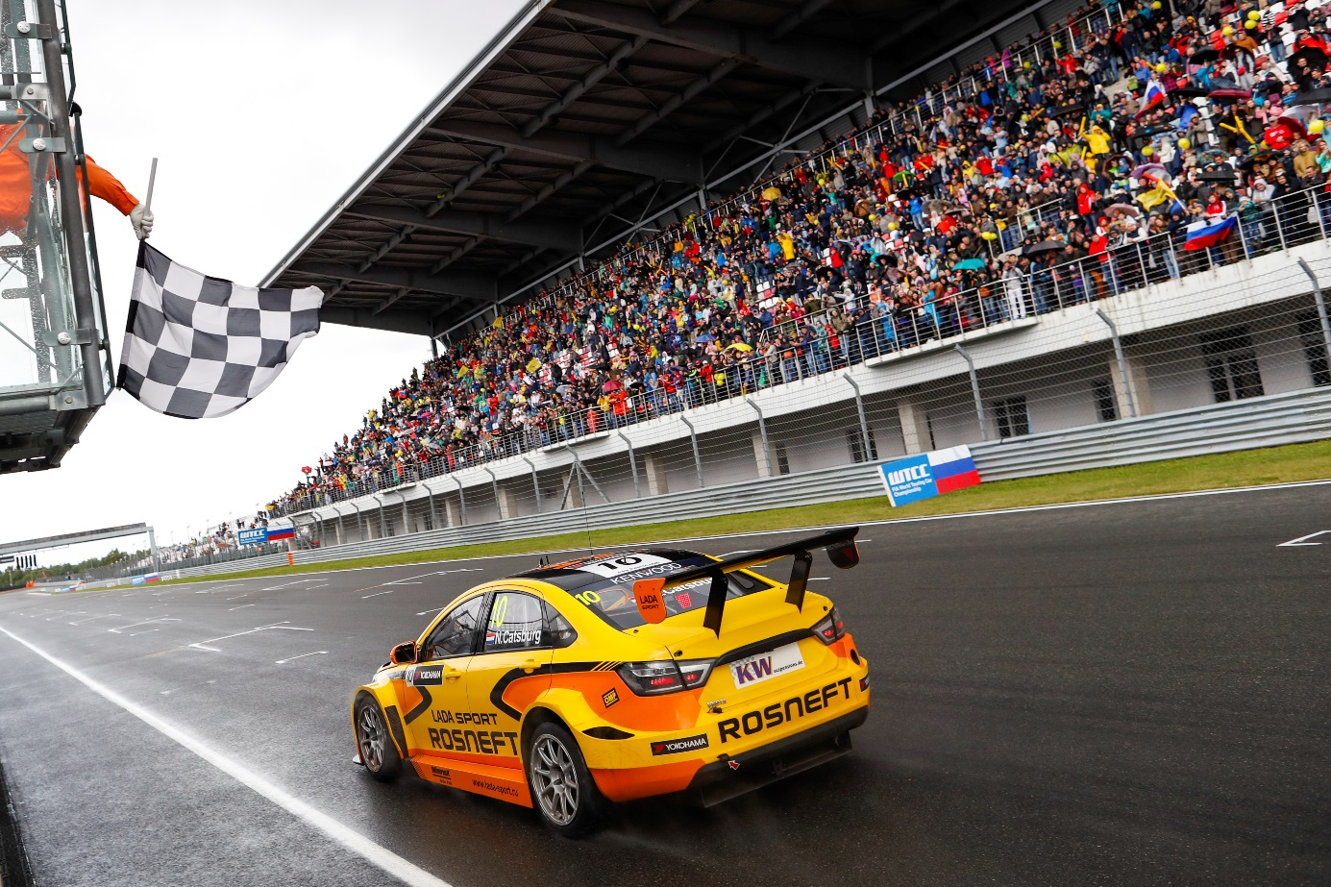

*Catsburg takes the victory for LADA Sport at WTCC Race of Russia*